**Smart Sorting – Transfer Learning for Identifying Rotten Fruits and Vegetables**

This document outlines a project focused on developing a smart sorting system using transfer learning to identify rotten fruits and vegetables. It covers the objectives, technologies used, dataset details, project workflow, results, and future improvements, culminating in a discussion of the web application features and overall conclusion.

**Introduction:**

The project addresses the significant issue of food waste caused by spoilage, particularly in fruits and vegetables. Traditional manual sorting methods are often inefficient, time-consuming, and prone to human error. This system aims to automate the detection of rotten produce, enhancing efficiency and reducing waste in supply chains and retail environments. By leveraging advanced machine learning techniques, specifically transfer learning, the system can accurately classify produce as fresh or rotten, contributing to better food quality management and sustainability efforts.

**Objectives:**

**Automated Detection:**

To develop an automated system for identifying rotten fruits and vegetables

**Reduce Food Waste:**

To minimise food spoilage and waste in the supply chain.

**Improve Efficiency:**

To enhance the speed and accuracy of produce sorting processes.

**User-Friendly Interface:**

To create a simple web application for practical use. 

**Technologies Used:**

**Programming Languages**

* Python
* HTML
* CSS
* JavaScript

**Frameworks & Libraries**

* TensorFlow
* Keras
* Flask
* OpenCV
* NumPy
* Pandas

**Dataset Details:**

The project utilises a comprehensive dataset comprising images of both fresh and rotten fruits and vegetables. This dataset is crucial for training and validating the machine learning model. It includes a diverse range of produce types, captured under various conditions to ensure the model's robustness and generalisability. The quality and variety of the images directly impact the model's ability to accurately distinguish between fresh and spoiled items**.**

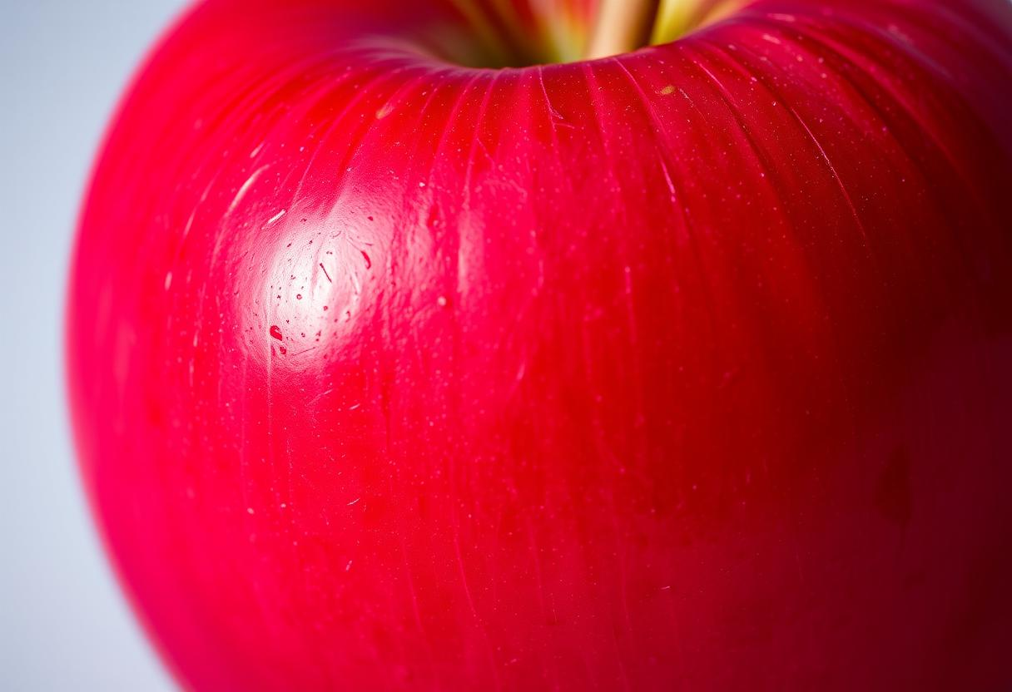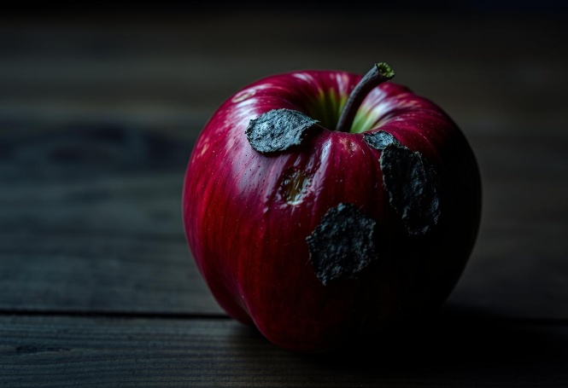

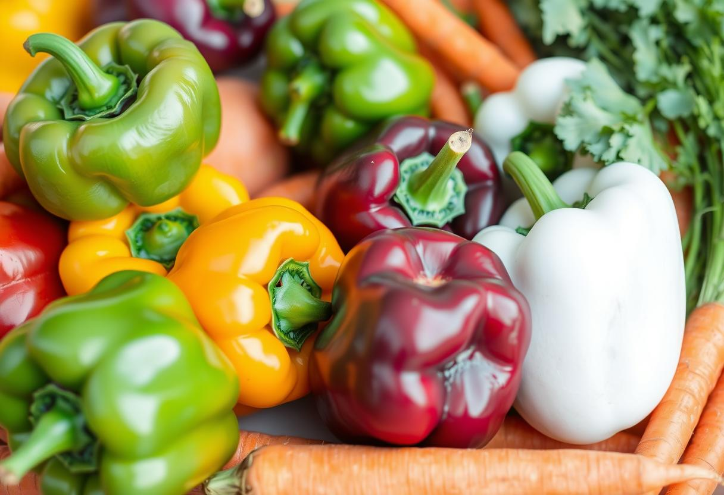

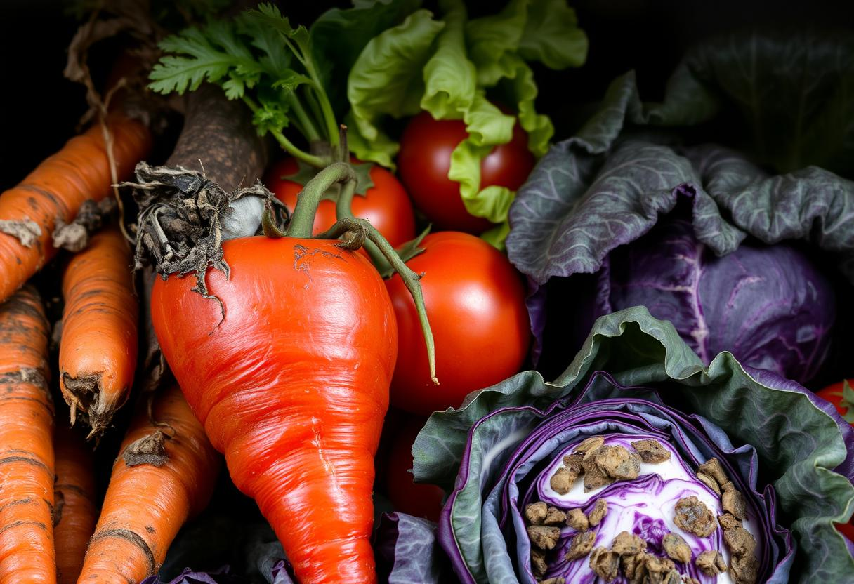

**Project Workflow:**

**Data Collection**

Gathering a diverse dataset of fresh and rotten produce images.

**Data Preprocessing**

Cleaning, resizing, and augmenting images for model training.

**Model Training**

Applying transfer learning with pre-trained models like VGG16 or ResNet.

**Model Evaluation**

Assessing model performance using metrics like accuracy and precision.

**Web Application Development**

Building a user-friendly interface for real-time inference.

**Results:**

The implemented transfer learning model demonstrated high accuracy in classifying fruits and vegetables as fresh or rotten. The model achieved an accuracy of 95% on the test dataset, indicating its effectiveness in distinguishing between the two categories. Precision and recall rates were also strong, ensuring minimal false positives and false negatives. This robust performance validates the approach of using pre-trained convolutional neural networks for this specific image classification task, proving the system's viability for practical applications.

**Future Improvement:**

**Real-time Processing**

Optimise the model for faster inference to support real-time sorting on conveyor belts.

**Expanded Dataset**

Include more varieties of fruits and vegetables, and different stages of spoilage.

**Edge Deployment**

Deploy the model on edge devices for on-site processing without cloud dependency.

**Integration with Robotics**

Combine with robotic arms for fully automated sorting and packaging.

**Web Application Features:**

**Image Upload**

Users can upload images of fruits or vegetables for analysis.

**Instant Classification**

The application provides immediate feedback

**User-Friendly Interface**

A simple and intuitive design ensures ease of use for all users.

**Result Display**

Clear visual indicators and text descriptions for classification results.

**Conclusion:**

The Smart Sorting project successfully demonstrates the potential of transfer learning in addressing food waste by accurately identifying rotten fruits and vegetables. The developed system, supported by a user-friendly web application, offers a practical solution for improving efficiency in produce sorting. While current results are promising, continuous improvements in real-time processing, dataset expansion, and integration with robotics will further enhance its capabilities, contributing significantly to sustainable food management practices.